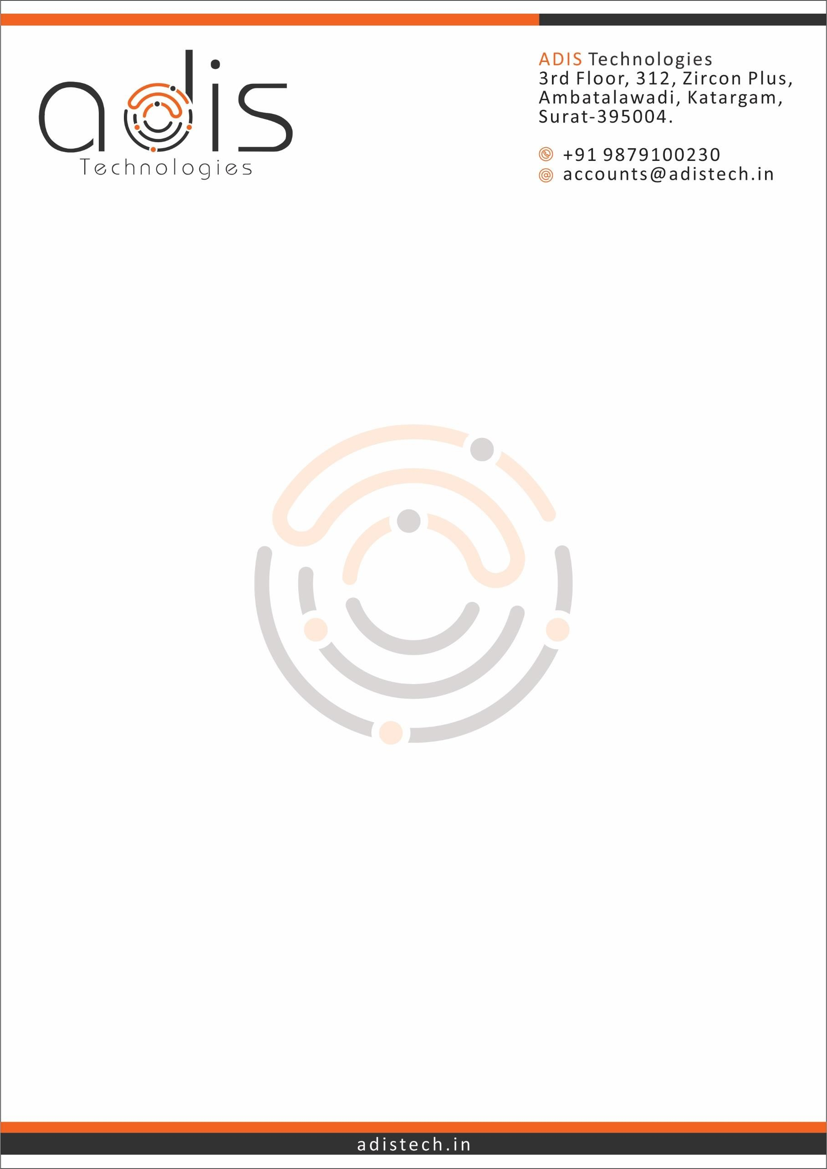

Completion Certificate for Internship

**Date: 20th April 2025**

**Dear Mistry Vatsal Rohitkumar ,**

This is to certify that Mistry Vatsal Rohitkumar has successfully completed an internship as **a** Python Developer at Adis Technology, from **20th January 2025 to 20th April 2025**.

During the internship, Vatsal as a Python Developer Intern, and actively contributed to the development and implementation of a real-time, document-aware AI chatbot system. The project was based on cutting-edge technologies, primarily utilizing Llama 3.2 as the core large language model, supported by Retrieval-Augmented Generation (RAG) techniques. The chatbot system was designed to interact with various data sources including PDF documents, Word files, websites, Wikipedia content, and direct user queries.

Vatsal worked on integrating LLM models using LangChain, designing user interfaces with Streamlit, and configuring ChromaDB for efficient data retrieval. He ensured smooth frontend-backend interaction, handled multiple file formats, and focused on testing and debugging to maintain performance and reliability.

The internship concluded successfully with final integration, testing, and submission of a detailed report. We congratulate Mistry Vatsal Rohitkumar and wish them the best in their future endeavors.

**Regards,**

**Ashish Savaliya**

**[Mobile - +91 9825686468]**

**[Email –** [**ashishpsavaliya@gmail.com]**](mailto:ashishpsavaliya@gmail.com) **[CEO – Adis Technologies]**